RC-Asia-China-Mirror-Lion and Grapes TWO

Manichaeism originated in Mesopotamia in the third century C.E. as a consciously syncretistic blend of Christian, Zoroastrian, and gnostic ideas, and was disseminated through vigorous proselytization in the Sassanian and Roman empires during the next two centuries.

An intolerant pogrom of Roman Catholic zealots suppressed it in the West by the sixth century, but similar persecutions by Zoroastrian and Muslim zealots proved less successful in the East where Manichaeism survived within the Islamic realm well into the Abbassid period.

Manichaeans were thus “encouraged” to migrate eastward to Central Asia in substantial numbers, where Manichaeism attained recognition as the official state religion in the Uighur Empire during the eighth and ninth centuries. Since Uighur mercenaries played a prominent role in the defense of the western frontier of China, Manichaeism was initially tolerated, although it was officially proscribed in 843 C.E. by Confucian zealots who saw it as a threat to their control, yet it persisted clandestinely until 1400 C.E.

Manichaean art has left its mark in Xinjiang. All the three temple complexes of Turfan, i.e.Toyuk, Bezeklik and Sangim, contain many Manichaean grottoes which have been studied in great detail by Prof Chao (Zhao) Huashan of the Bejing University. According to his research, the main and side chambers of the Toyuk Grotto No.2 contain pictures of the Manichaean treasure trees accompanied by envoys of light, and of the meditations of the disciples, etc. These pictures are repeated also in the Toyuk Grotto No 7.

The Bezeklik temple complex too has many grottoes devoted to Manichaean subjects, like the veneration of the divine tree, portraits of Mani's followers in Persian dress, as well as a sketch of a Manichaean temple (Grotto No.38 B. according to the classification of Professor Chao Huashan). From some of these Bezeklik caves there have been discovered also Uighur inscrip- tions which help in the dating of the caves.

At Sangim, Prof Chao could visit only two Manichaean temples which he termed as the Northern Temple and the Southern Temple. They also contain many pictures depicting the Manichaean subjects such as the Tree of Life, the Tree of Death, the Orchard of Treasure Trees, etc.[3](http://www.ignca.nic.in/ks_41029.htm" \l "_ftn3) We know from Manichaean texts that at the core of the Manichaean creed was a dualist doctrine that postulated two kingdoms: the Kingdom of Light *(guangming wangguo)* and the Kingdom of Darkness *(hei'an wangguo).* These two kingdoms are represented by two trees as mentioned above. There is an explanation of the nature of these two trees in the Book of Giants *(Juren shu)* that says: Virtue is expressed by Light or by the Tree of Life which occupies the East, the West and the North, while to the South there is the Tree of Death. The *Kephalais* (Essentials of the Faith), an ancient Manichaean manuscript written in Coptic discovered in Egypt during the 1930s explains that these two trees are the Tree of Virtue and the Tree of Evil. The trunk of the two trees twist around each other in two places. The relative positions of the two trees also illustrate the Manichaean doctrine of three moments i.e. the Initial Moment; the Median Moment, and the Ultimate Moment.

According to the *Compendium of the Teaching of Mani: the Buddha of Light,* a Manichaean temple has five sections containing a lectorium, a hall for instruction, a hall for prayer and penitence, a hall for preaching, and a monk's hospice. In these five halls, monks and their followers lived together, engaged in spiritual cultivation and character improvement. According to Prof Chao, the imposing Northern Mosque in Sangim typifies the Manichaean temple.

From the chronological point of view the halls are divided into two periods. In the former period, the layout has several features: the main chamber is relatively wide, the side chambers are also quite spacious, but the prayer and penitence hall is rather small. The frescoes of the first period, can be placed in the early seventh century specially the painting of the Grotto No. 2 of Toyuk. The boar heads of this period are surrounded by a ring of white circles set in black, resembling a string of pearls imitating Persian motifs of the Sassanian period. Toyuk grottoes show two portraits of donors wearing striped cloaks with their hands raised. Prof Chao Huashan has described this dress as that of Macedonian aristocracy. At that time Macedonia was an important centre of Manichaean faith. The Manichaean grottoes of the second period (9th century) are distinguished by the presence of the Uighur script and their large scale showing the might of the Uighur empire.

Manichaeism was very popular in China during Tang Dynasty (618-907), the documents of wh)ch period yield various , names like *Moni, Momoni, Momonifa* (law of Mani), *Xiao moni* (small Mani), *Da Moni* (great Mani), *Moni shi* (Mani priest) etc. After Tang, these names disappeared, and Manichaeism was popularly known as *mingjiao* (the Bright Religion). During the Ming Dynasty (1368-1644), the government could not tolerate a non-government organization using the imperial title "Ming", hence, Manichaeism was banned, and its activities went underground. As I have alluded to earlier, durirlg the post-Han period of political instability, Manichaeism arrived in China and was utilized by rebel leaders to mobilize followers. Such a phenomenon developed after the Song Dynasty (960-1279) , particularly along the coastal regions where secret soci eties and rebellions sprang up by leaps and bounds. Even during the Song Dynasty there was the interesting occurrence in the two coastal provinces of Zhejiang and Fujian which is known as *chicai shimo* (literally, "eating vegetables and serving the devil"). In *Fozu Tongji,* which is an important historiography of Buddhism in China compiled by Buddhist scholars during 1258-1269, there is an account which categorically identifies these vegetarian followers of the "devil" as belonging to the Association of *Mingjiao,* i,e. the new Chinese name for Manichaeism. The account says that the leader wore a headgear of violet colour, while the followers wore white costumes. They worshipped the white Buddha.[4](http://www.ignca.nic.in/ks_41029.htm" \l "_ftn4) Many of these followers demonstrated their rebellious spirit and were quelled by the Song government. After that, all subsequent governments were supressive against Manichaean activities. albeit the Manichaean followers' tenacity in their faith and in their organized activities.

The Quanzhou county of Fujian province was a place that used to have Manichaean activities from Song Dynasty onwards. This was also the place where there was an Indian community during the Tang and Song (and even afterwards), and where the remains of a Hindu temple have been found. Whether the presence of the Indian community and the Manichaean activities there had any connection with each other we are not able to ascertain. Historical reference alludes to a Manjchaean temple built at Quanzhou in 1148. Archaeological excavations at the ruins of this temple at Huapiao Hill in this county have yielded several tens of broken pieces of black porcelain bowls of Song vintage, one of which bears the letters "mingjiaohui" (Association of the Bright Religion).[5](http://www.ignca.nic.in/ks_41029.htm" \l "_ftn5)

In the Quanzhou Museurl1 of the History of Maritime Intercourses *(Quanzhou haiwai jiaotongshi bowuguan)* there is a carved Buddha of the Mani Light which was recovered from the ruins of the Mani temple (of Song Dynasty) at Huabiao Hill. The sculpture is round in shape, resembling a sun. While a Buddha-Iike deity fills the circular sculpture, the deity wears a Chinese Buddhist robe and with a typical Chinese face. The design in the background depicts sun rays emitting from the deity. This very interesting artifact deserves close examination. It looks like that the *Mingjiao* followers were worshipping an alternative Buddha who, they might have wished, would bless the poor masses for a change -unlike the usual prevalent Buddhas in China who had been quite monopolized by the rich and high-ups. That Manichaeism came all the way from the Western Hemisphere to China to make the noble ideas and ideals serve the down-trodden is a fascinating historical phenomenon. I hope my brief account stimulates more Indian scholars to study it in collaboration with Chinese scholars.

In conclusion, Manichaeism was a religio-cultural movement that had a very significant influence on Chinese development it is clear that its activities both helped spread the popularity of the Buddha and completed with the Buddhist institution to the extent that the Manichaean followers were maligened as "vegetarian followers of the devil". As the Manichaean culture was internalized by the oral literature of the common people the movement has lost much of its distinct traces as well. This, however, should not inhibit us from making further inquires about this fascinating movement which also bears a dimension of Sino-Indian interface it only indirectly.

Chao, Huashan, "New evidence of Manichaeism in Asia. A description of some recently discovered Manichaean temples in Turfan" in *Monumenta Serica,* No 44 (1996), pp 267-315.

[4](http://www.ignca.nic.in/ks_41029.htm" \l "_ftnref4). *Fozu Tongj* (Chronology of the reign of the Patriarch Buddha), *juan* 48

[5](http://www.ignca.nic.in/ks_41029.htm" \l "_ftnref5). See Zhuang Weiji, "Quanzhou Monijiao Chutan" (Tentative studies on Manichaeism at Quanzhou) in *Shijie Zongjiao Yanjiu* (Joumal of Studies on world Religion), Beijing, No.3, 1983, pp. 72-82.

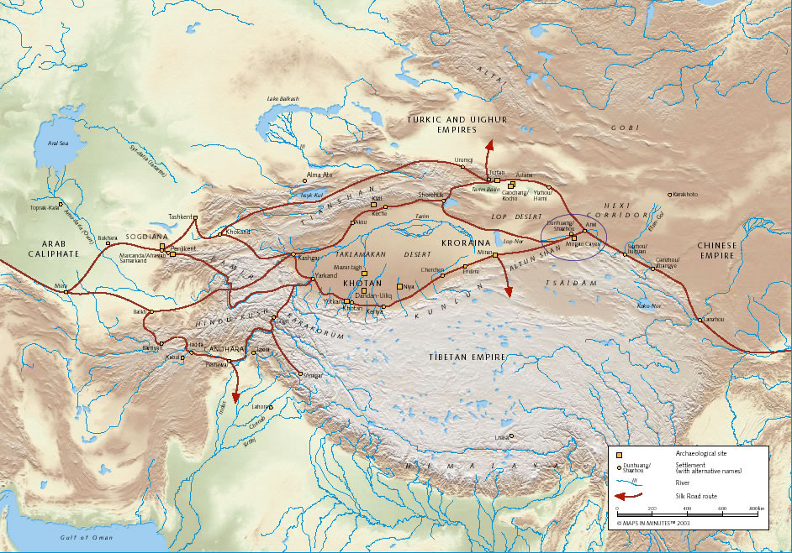

http://www.csanet.org/newsletter/fall08/silkroadmap2.jpg